# Mockito exercises

**Exercise 1: Mocking and Stubbing**

Scenario: You need to test a service that depends on an external API. Use Mockito to mock the external API and stub its methods.

Steps:

1. Create a mock object for the external API.

2. Stub the methods to return predefined values.

3. Write a test case that uses the mock object.

---------------------------------------------------------------------------------------------

**SOLUTION**

Ensure Folder Structure Looks Like:

MockitoStubbingDemo/

├── src/

│ ├── main/

│ │ └── java/

│ │ └── com/example/

│ │ ├── ExternalApi.java

│ │ └── MyService.java

│ └── test/

│ └── java/

│ └── com/example/

│ └── MyServiceTest.java

├── pom.xml

**Code Files**

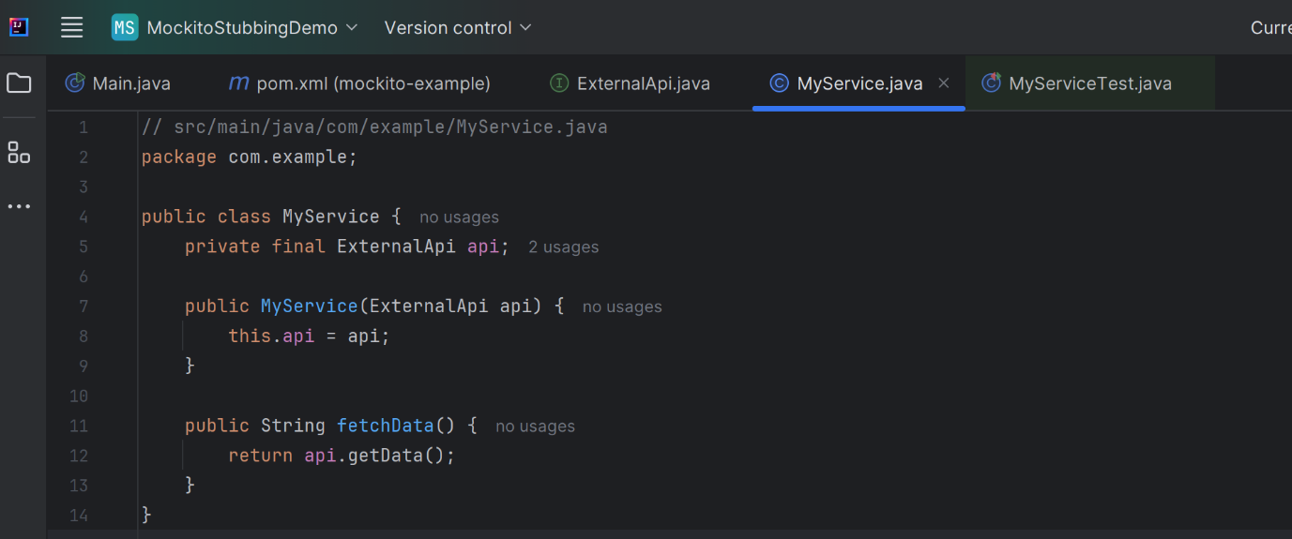

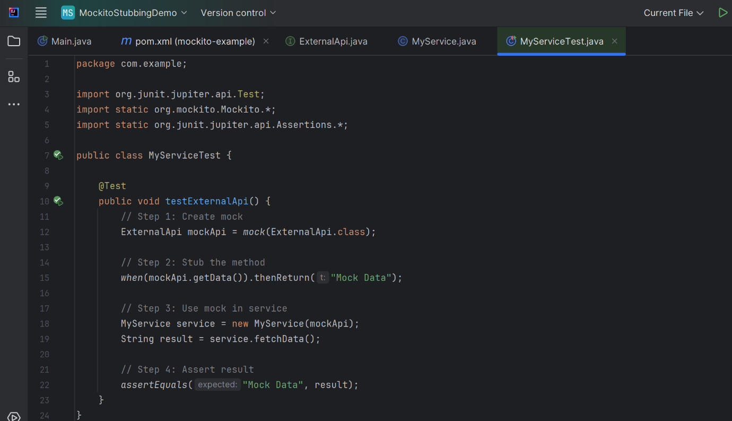

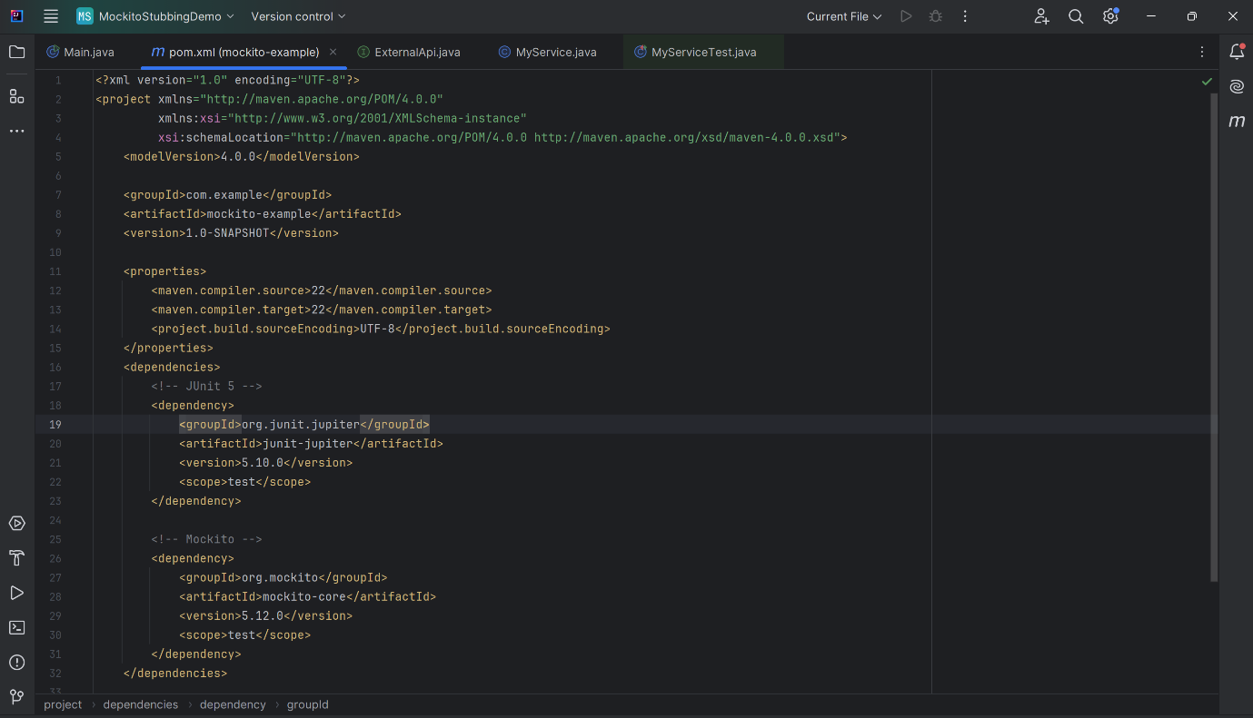

**OUTPUT**

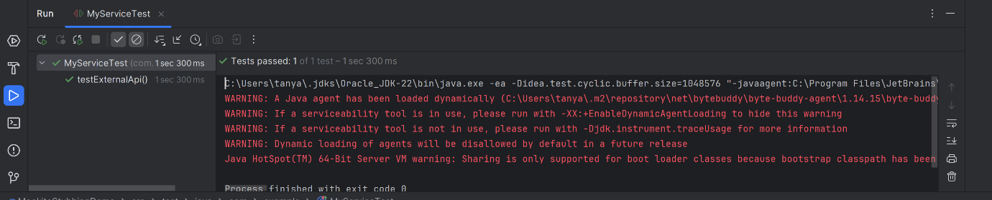

**Exercise 2: Verifying Interactions**

**Scenario: You need to ensure that a method is called with specific arguments.**

**Steps:**

**1. Create a mock object.**

**2. Call the method with specific arguments.**

**3. Verify the interaction.**

**======================================================================**

**SOLUTION**

**VerifyingTransaction/**

**├── src/**

**│ ├── main/**

**│ │ └── java/**

**│ │ └── ExternalApi.java, MyService.java**

**│ └── test/**

**│ └── java/**

**│ └── MyServiceTest.java**

**├── pom.xml**

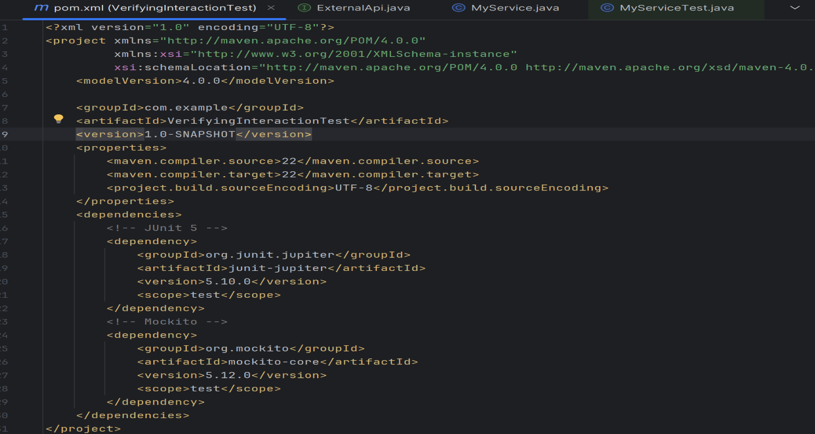

**CODE FILES**

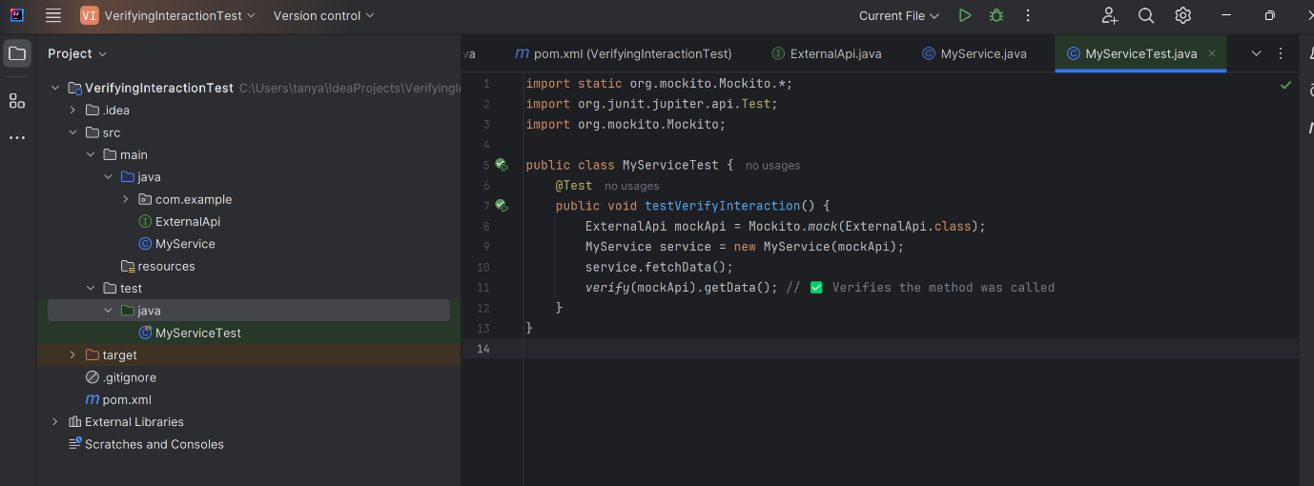

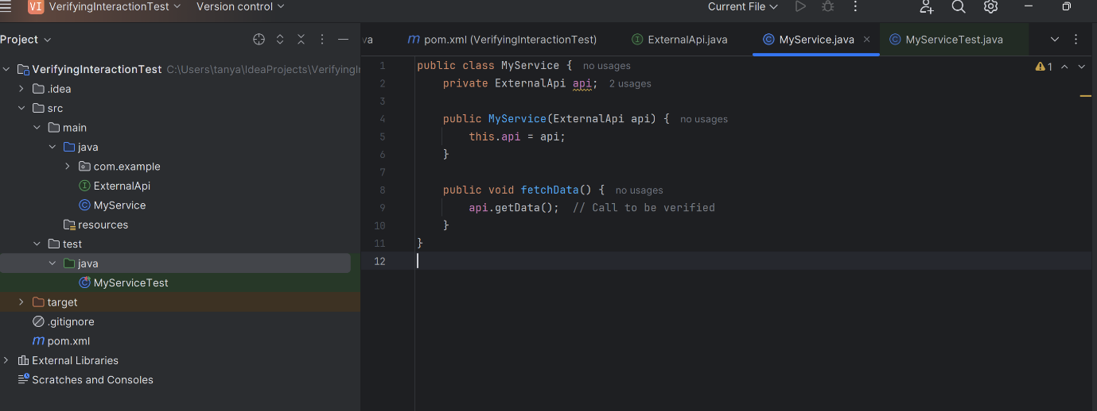

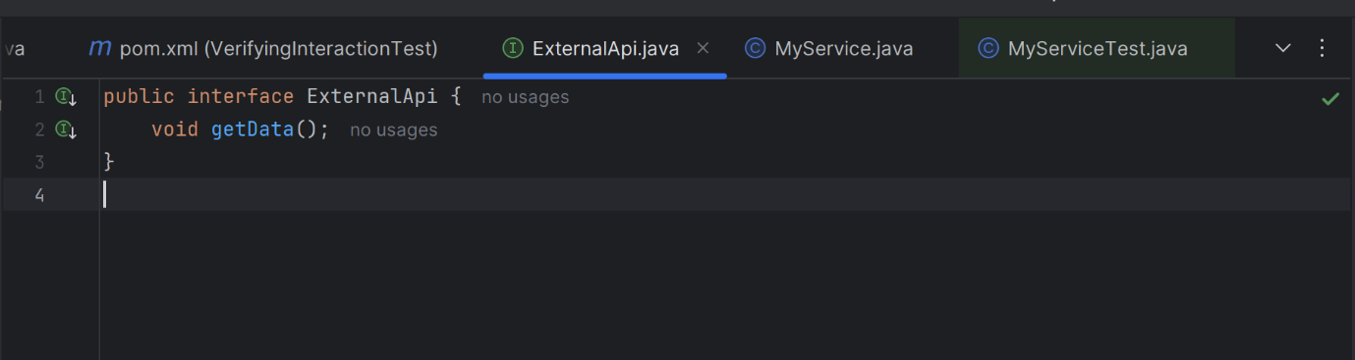

**OUTPUT**



